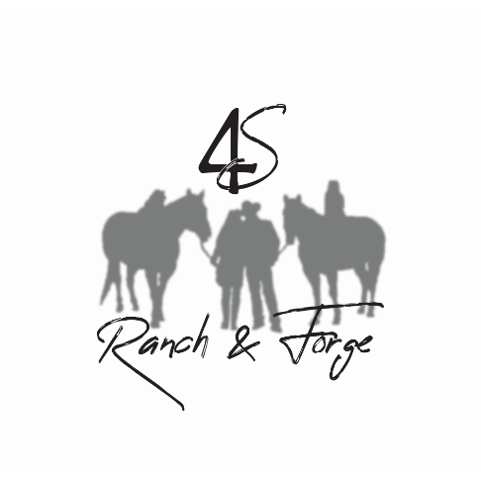

4S Ranch & Forge, LLC
Birthday Party FAQ
Address:
12238 W Cty Rd A, Evansville WI 53536

How long is a typical ranch birthday party?
Usually 2 hours is plenty of time for riding, a craft, gift opening and cake.

Typical Age Range for Birthday Parties:
5-14 yrs of age!

Is there a minimum number of kids to qualify for a “party?”
Yes, the minimum number of kids is 3, including the birthday child!

Is there a maximum number of kids for a birthday party?
Yes, the maximum number of kids is 8 including the birthday child!

What do birthday parties include?
4S Ranch Horses, riding equipment, helmets, and 4S Ranch Staff.
All programming including a craft and games.

What don’t 4S Ranch parties include?
Cake, presents, decorations, or party favors for guests. We do not offer food or beverages.
We also do not babysit- we facilitate an amazing program but are not a childcare provider. All parents/or the group leader(s) must remain on site. At least one adult will need to remain with the group.

What is the price for a party?
$225

A typical schedule looks like this:
1:00- Everyone arrives and a tour is given along with rules and what to expect!
1:15-2:15- Grooming, leading and riding horses! Best part of the day! Group Photo
2:15-2:30- Horse Craft and/or game
2:30-3- Sing happy birthday, cake, and present opening!
3:00- Farewell and thank you!

4S Ranch & Forge LLC is looking forward to helping you plan your birthday party, please call to schedule or for more information!
608-235-9404

